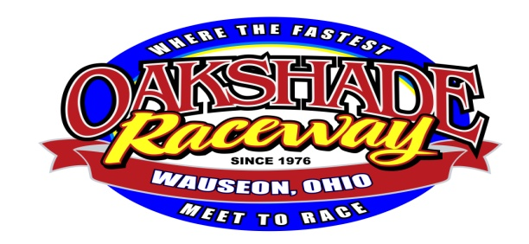
2017 Schedule
Full show is UMP Late Models, UMP Sportsman, Bombers, & Compacts

April 29th: Bill Reckner Memorial-UMP Sportsman, Bombers & Compacts
May 6th: Oakshade/Attica Late Model Challenge plus UMP Sportsman, Bombers & Compacts.
May 13th: Full Show
May 20th: Full Show
May 27th: ALMS $2000 to win UMP Late Models plus UMP Sportsman, Bombers, & Compacts
June 3rd: Full Show
June 10th: Wallace Racing Products Night- Full Show
June 17th: 28th Annual Barney Oldfield Race $5300 to win ALMS UMP Late Models plus UMP Sportsman, Bombers, & Compacts
June 24th: American Ethanol Late Model Tour $4000 to win Plus UMP Sportsman, Bombers, & Compacts
July 1st: Oakshade/Attica Late Model Challenge- Memorial Night- Full Show
July 8th: American Vintage Cars- Full show
July 14th: Summer National DirtCar Tour- $5,000 to win Late Models plus DIRTcar Summit Modifieds $1,000 to win. Gates open Noon Race at 7:30 pm
July 15th: 19th Annual Birthday Race UMP Summer National Finale $10,000 to Win plus UMP Summit Modifieds & Compacts- Gates open 10am Race at 7:30 pm- Rain Date July 16th
July 22nd: Oakshade/Attica Final Late Model Challenge- Full Show
July 29th: Full Show

August 5th: Full Show
August 12th: Full Show
August 19th: Full Show
August 26th: Full Show
September 2nd: ALMS $2000 to win UMP Late Models plus UMP Sportsman, Bombers, & Compacts
September 9th: American Ethanol Modified Tour Presented plus UMP Sportsman, Bombers & Compacts
September 16th: Season Championship Night- Full Show
September 23rd: Papa Boiler Bomber Spectacular $1,000 to win! Plus UMP Late Models, UMP Sportsman, & Compacts
September 30th: Topless UMP Late Models, UMP Sportsman, Bombers & Compacts
October- Swap Meet
December 2nd: Awards Banquet
*Gates open @ 4pm Race @ 7pm unless noted.
*Schedule is tentative & may change!!
www.oakshaderaceway.com
419-337-6850

